Balancing the Balconies & Basements: A compassionate approach when strengths go rogue.

There are two sides to strengths. On one hand, they create value, thus creating a gateway to being accepted, belonging, and being of value to others. But strengths can also have a dark side if they are over-used. Instead of helping, they end up hurting … instead of equipping, they end up diminishing … instead of furthering the cause, they end up throwing a wrench in the works.

Gallup uses the terminology of Balconies and Basements to describe the difference between strengths at their best, and strengths at their worst.

The Biology of Balconies and Basements

Our biological state can have a lot to do with this best-to-worst variance. When in the Blue Zone of calm-connect/flow-flourish, our cognitive and relational abilities are enhanced. This permits strengths to generate ease, productivity, and wellbeing. In this state, strengths operate strategically and serve as “Balconies.”
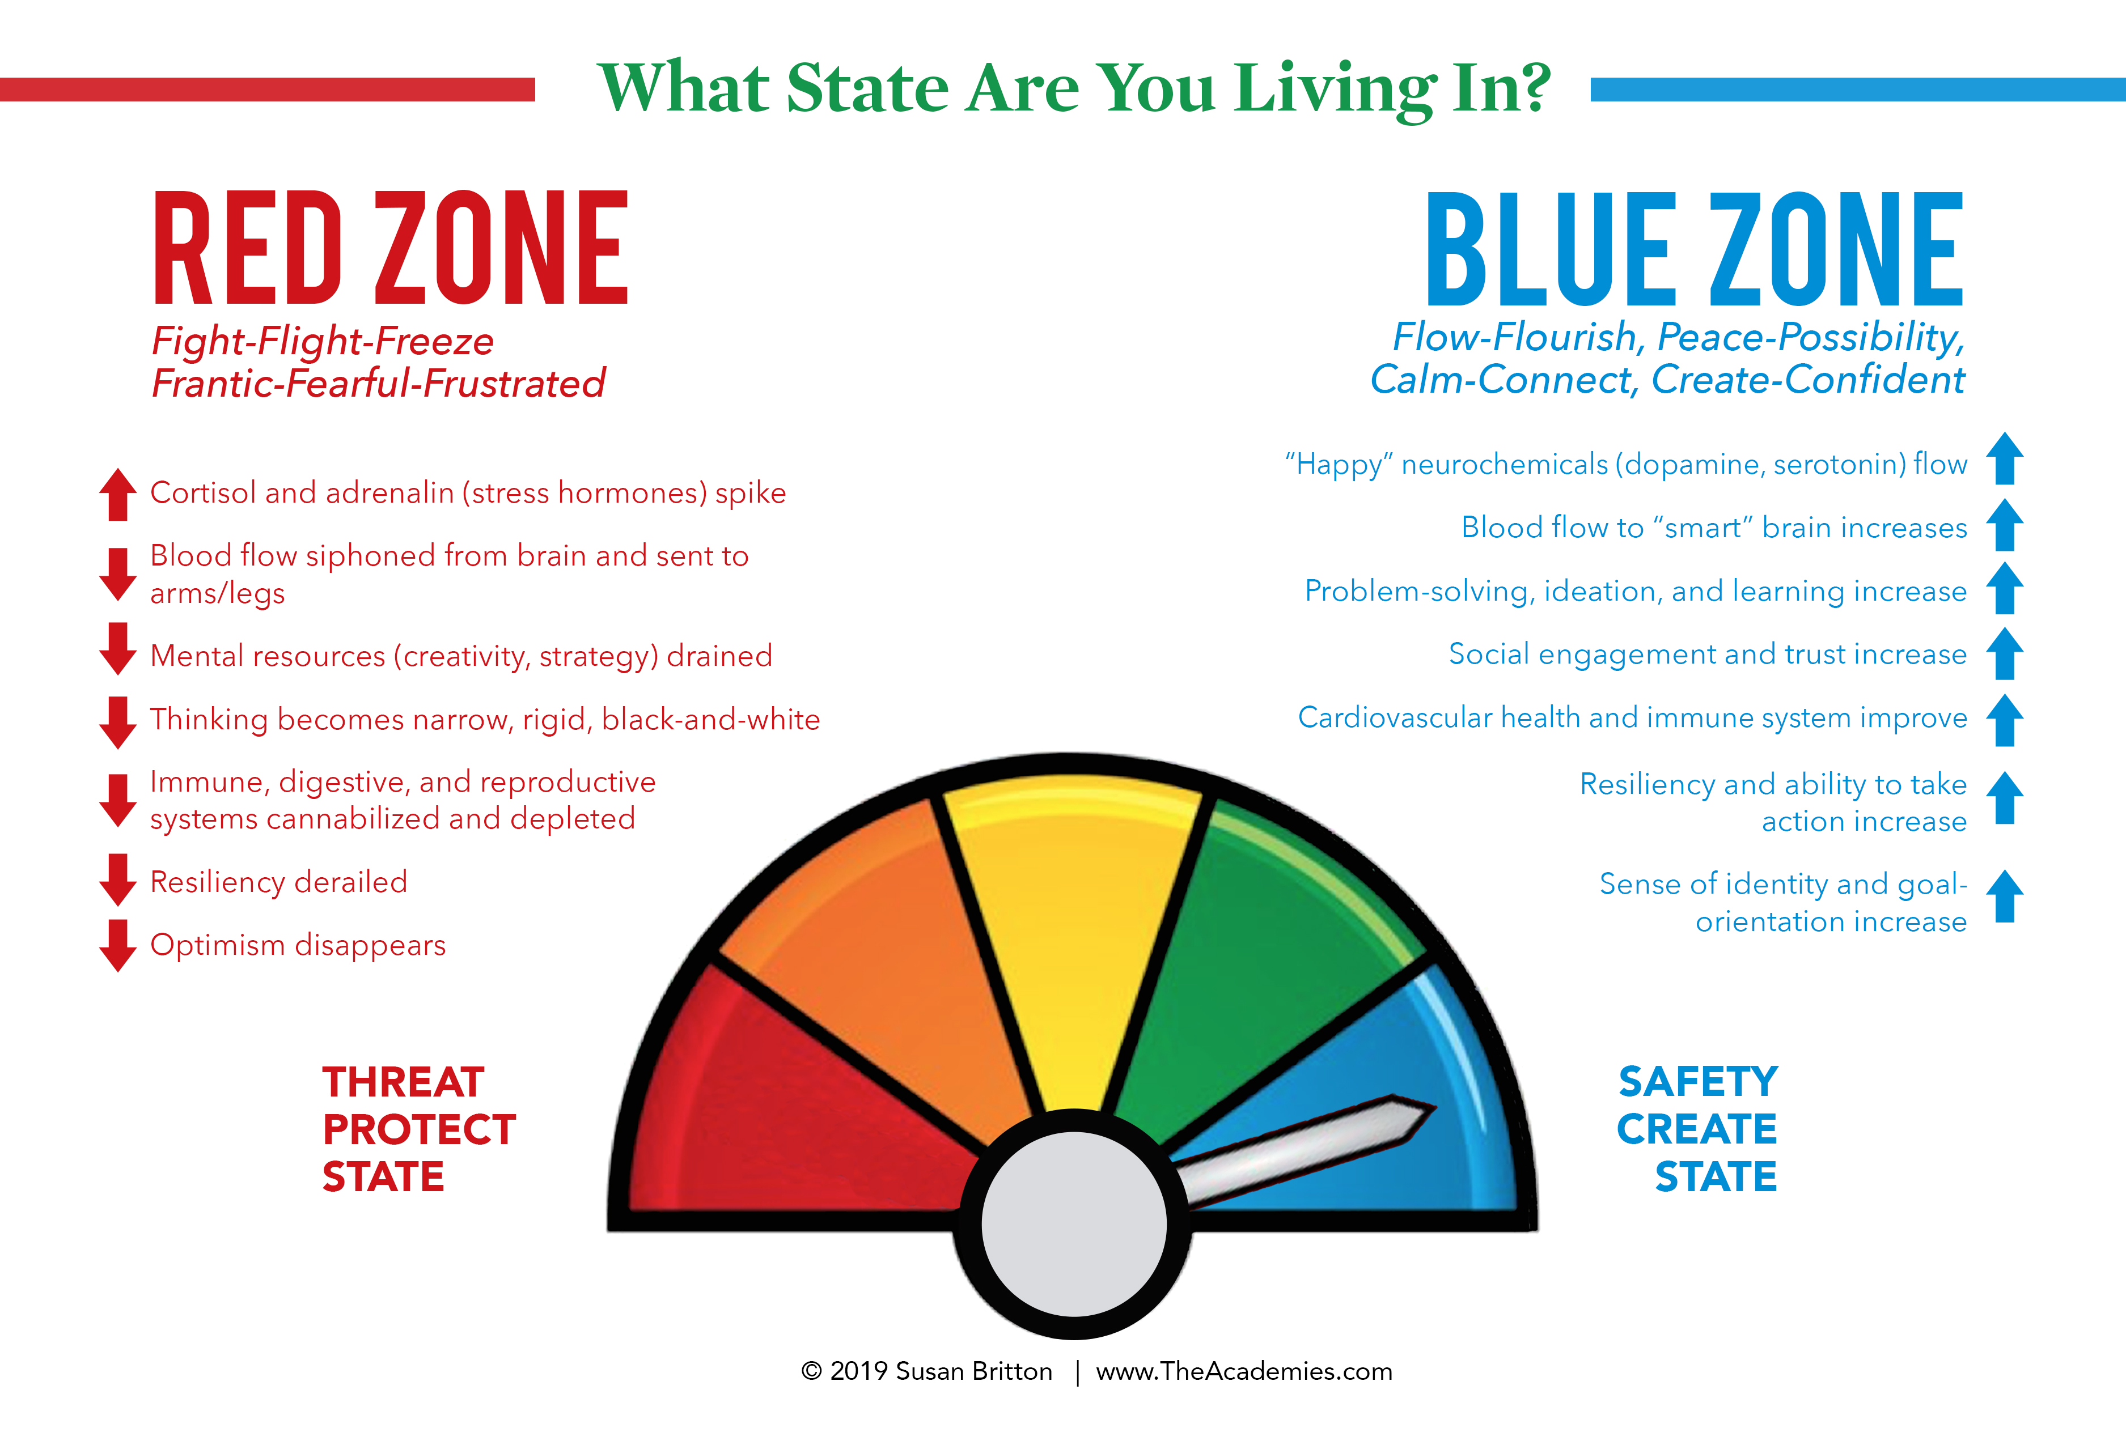
Conversely, when in the Red Zone of fight-flight, strengths can become “Basements.” Our focus becomes narrow—like a racehorse wearing blinders, we can’t see the big picture. The broader periphery fades and we are dependent on someone else to see the strategic landscape. And because cortisol is spiked or sustained beyond what is good for us, a strength when used in the Red Zone becomes a caricature of its original essence—forced, overdone, and even contorted.

For example, the Balcony of the Analytical strength allows people to think through all the facts that affect a situation; yet as a Basement, it can turn arrogant or miss the human side of the equation. The Balcony of Adaptability creates an ability to be flexible; yet as a Basement, it turns to indecisiveness and lack of progress.

Upon recognizing that our strengths have gone rogue, it’s not unusual to feel bad—embarrassed, misunderstood, sad, frustrated, ashamed. These feelings often just cue up another round of being in the Red Zone.

It’s Not Your Fault…We’re All Wired This Way!

Don’t feel alone. Every human being on the planet has a tendency to over-use strengths.

Consider this biological-evolutionary hypothesis: If strengths give us a sense of value and belonging, then using them is based in an evolutionary drive to be accepted, appreciated, and included in our “tribes”—families, teams, friend groups, communities.

Yet in times of stress, our biological fight-flight reaction diminishes our cognitive abilities. And so we slip into default behaviors that make us feel safe—the familiar, reliable strengths that brought us acceptance and appreciation in the past. Unfortunately, they are used without the benefit of strategic thinking and relational engagement (the two key ingredients that often disappear in a fight-flight state).

And thus, Balconies turn to Basements, as strengths are over-used, warped, and distorted. Analytical rigor becomes analysis-paralysis; empathetic caring twists into drama-trauma; the reflective insights of intellection sink into rumination; and so on.

The Way Out of the Catch 22

Self-compassion is the way out! Why? Because self-compassion shifts the body’s biology out of the Red Zone of fight-flight toward the Blue Zone of flow-ease. The steps in the table below can offer a self-compassionate path out of strengths in the Basement and back to strengths in the Balcony.

PATH: | Restoring Strengths from Basement to the Balcony
Awareness | I’m noticing that I’m over-using my strength of ___________________  When I over-use this strength, it looks like this:  _____________________________________________________________  _____________________________________________________________
Self-awareness—present | Here’s how over-using my strength is affecting me:  _____________________________________________________________  Here’s how over-using my strength is affecting others:  _____________________________________________________________
Self-awareness—future | Long-term unintended ramifications of over-using this strength include:  _____________________________________________________________  _____________________________________________________________
Compassionate curiosity: | I might be over-using this strength because (check all that apply):  It’s familiar, comfortable behavior to me  It’s served me well in the past  I got triggered and reacted without thinking  It’s been rewarded by others in the past  It’s a strength that I value  I didn’t realize I was over-using it  It gives me a sense of control  It feels like it’s helping me (even if it’s not in the long run)  I don’t know what else to do  Other
Experiment with new tack: | Re-focus on a contrasting strength.  Example, shift out of Empathy (a relational theme) and into Achiever (an executing theme).  The contrasting strength I’ll use is: ________________________  Here’s how I’ll use it: ____________________________________  Turn strengths inward.  Example, if Empathy is out-of-alignment, consider being empathetic toward yourself … what is the most empathetic thing you could do for yourself?  Here’s how I can turn this over-used strength inward: ____________  Re-adjust the strength in a more strategic manner.  Example, if a person with Activator is not pausing long enough to hear herself think, instead use Activator to initiate silence, to create a plan for slowing down and considering the full trajectory, to activate a plan that invites others to contribute to the plan, etc.  Here’s how I can re-adjust my over-used strength in a more strategic manner:  ____________________________________________________________  ____________________________________________________________  ____________________________________________________________

